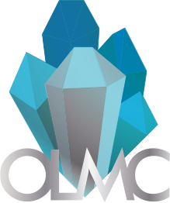
Ottawa Lapidary & Mineral Club (OLMC)
Ottawa, Ontario
(613) 700-4367

Member Consignment Form for Auction of May 2023
Theme: Spring Cleaning May 20th-May 27th, 2023
Section 1: Limit of 5 auction and 5 buy it now items per member (consignment items)
Name of Seller | Click or tap here to enter text. | Email Address | Click or tap here to enter text.
Name of item | Click or tap here to enter text. | File Name of Picture
Date of Delivery  (email us for instruction) |  | Click or tap to enter a date.
Item type (Mineral Specimens, Lapidary Slab, Cabochons, Faceted Gemstones, Jewelry, other) |  | Choose an item.
Buy it now or Auction Item |  | Choose an item.
Member Item or Club Donation |  | Choose an item.
Starting Bid/ Buy it Now price ($CAD) |  | Click or tap here to enter text.
Item Description (Dimensions, features, locality, country of origin, etc.)

Disclaimer: Participants are responsible to declare any revenue to the CRA and deduct applicable taxes. More information here: https://www.canada.ca/en/revenueagency/services/tax/individuals/topics/about-your-tax-return/tax-return/completing-a-tax-return/personal-income/reporting-income.html
2023 members who have not renewed their memberships will be required to pay their membership fees and fill out the attached membership form or fill it at the end of our newsletter here: http://www.olmc.ca/news/mar23.pdf
The deadline to submit the forms and drop off the consignment items at Kerry’s May 13th, 2023.

