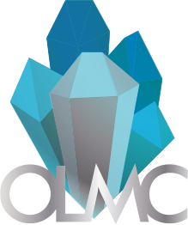Ottawa Lapidary & Mineral Club (OLMC)

Ottawa, Ontario

(613) 700-4367

**Member Consignment Form for Auction of May 2023**

**Theme:** Spring Cleaning May 20th-May 27th, 2023

**Section 1: Limit of 5 auction and 5 buy it now items per member (consignment items)**

|  |  |  |  |
| --- | --- | --- | --- |
| **Name of Seller** |  | **Email Address** |  |
| **Name of item** |  | **File Name of Picture** |  |
| **Date of Delivery**  **(email us for instruction)** | |  | |
| **Item type** (Mineral Specimens, Lapidary Slab, Cabochons, Faceted Gemstones, Jewelry, other) | |  | |
| **Buy it now or Auction Item** | |  | |
| **Member Item or Club Donation** | |  | |
| **Starting Bid/ Buy it Now price** ($CAD) | |  | |
| **Item Description** (Dimensions, features, locality, country of origin, etc.) | | | |
|  | | | |

**Disclaimer:** *Participants are responsible to declare any revenue to the CRA and deduct applicable taxes. More information here:* <https://www.canada.ca/en/revenueagency/services/tax/individuals/topics/about-your-tax-return/tax-return/completing-a-tax-return/personal-income/reporting-income.html>

*2023 members who have not renewed their memberships will be required to pay their membership fees and fill out the attached membership form or fill it at the end of our newsletter here: http://www.olmc.ca/news/mar23.pdf*

The deadline to submit the forms and drop off the consignment items at Kerry’s May 13th, 2023.