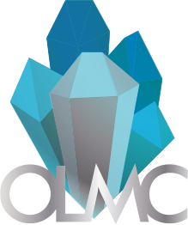
Ottawa Lapidary & Mineral Club (OLMC)
Ottawa, Ontario
(613) 700-4367

Member Consignment Form for Auction of Holiday 2021
Theme: Mineral Specimens, Lapidary Slab, Cabochons, Faceted Gemstones, Jewelry
Section 1 (reserved for seller) (limit of 5 auction and 10 buy it now items per member)
Name of Seller |  | Email Address
Name of item |  | File Name of Picture
Date of Delivery
(email us for instructions)
Item type (Mineral Specimens, Lapidary Slab, Cabochons, Faceted Gemstones, Jewelry)
Buy out or Auction Item
Member Item or Club Donation
Starting Bid ($CAD)
Item Description (Dimensions, features, locality, country of origin, etc.)

