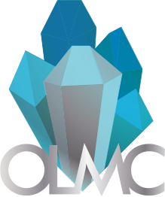Ottawa Lapidary & Mineral Club (OLMC)

Ottawa, Ontario

(613) 700-4367

**Member Consignment Form for Auction of September 2021**

**Theme:** Mineral Specimens, Lapidary Slab, Cabochons, Faceted Gemstones, Jewelry

**Section 1 (reserved for seller)(limit of 5 auction and 10 buy it now items per member)**

|  |  |  |  |
| --- | --- | --- | --- |
| **Name of Seller** | Click or tap here to enter text. | **Email Address** | Click or tap here to enter text. |
| **Name of item** | Click or tap here to enter text. | **File Name of Picture** |  |
| **Date of Delivery**  **(email us for instructions)** | | Click or tap to enter a date. | |
| **Item type** (Mineral Specimens, Lapidary Slab, Cabochons, Faceted Gemstones, Jewelry) | | Choose an item. | |
| **Buy it now or Auction Item** | | Choose an item. | |
| **Member Item or Club Donation** | | Choose an item. | |
| **Starting Bid** ($CAD) | | Click or tap here to enter text. | |
| **Item Description** (Dimensions, features, locality, country of origin, etc.) | | | |
| Click or tap here to enter text. | | | |